**Testing-**

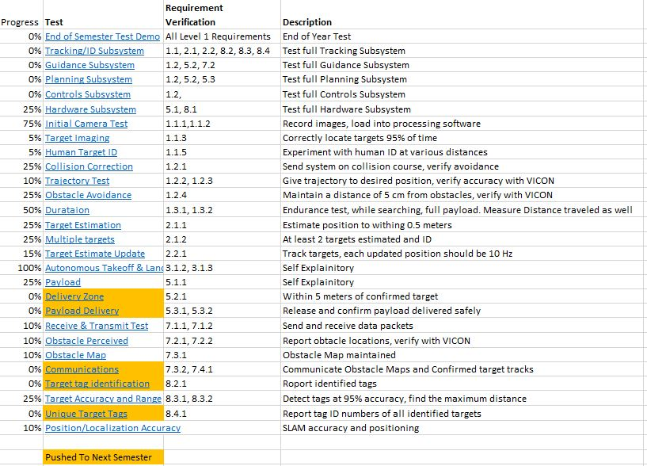The following will be a discussion of the test plan for project FlyNet. For reference, the tests to be performed are given below in Figure # and the test schedule is given in Figure %. Together they form the Test plan.

**Figure #: List of Tests**

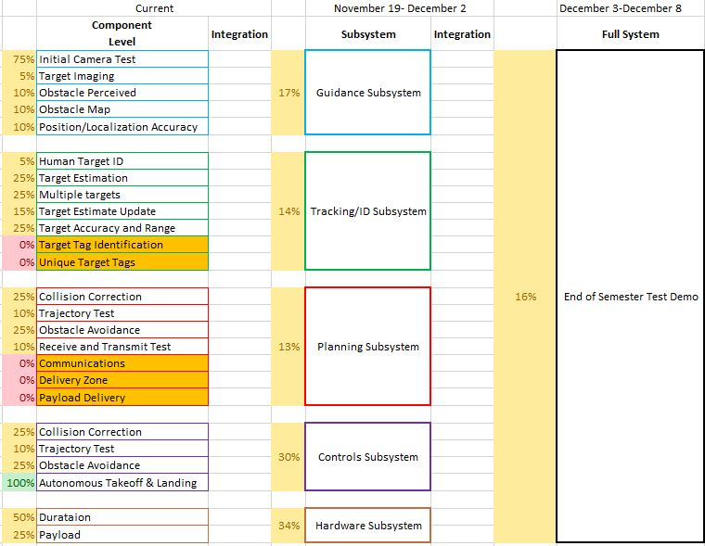**Figure %: Testing Schedule**

At the beginning of the project, the project scope was chosen for this semester. These were goals of where the project would be, in order to make those goals, a project plan needed to be created in order to make sure the product verified and validated the requirements. The entire project has more requirements than what this semester’s scope was, and also some requirements could be verified without the need for a test. The requirements that were determined to need tests to prove them were gathered and listed in Figure #. The first test listed is the End of Semester Test Demo which showcases the current functionality of the FlyNet system after one semester of progress. The next five tests are all subsystem tests. These were designed to show the functionality of each subsystem without integrating with the other subsystems yet. The rest of the tests listed are all component level tests to verify and validate that the chosen hardware and software will be able to satisfy the requirements.

The progress of each test is recorded next to the test name and the test schedule progress is updated accordingly. It is worth pointing out that the progress percentage of the subsystems are a weighted sum of the subsystem test itself and the component tests associated with that subsystem. For instance, if the Duration and Payload tests were completely done, but the hardware subsystem test has 0% progress, the Hardware subsystem listed in the Testing Schedule would read 75% complete. Each subsystem is weighted this way in the schedule and the same goes for the End of Semester Test Demo, it is a weighted sum of the subsystems.

Each test name given in List of Tests is linked to a respective test sheet. The test sheet is where the detailed description of each test is, as well as the procedure and documentation of the completed test. The procedure is needed to ensure if the test is run multiple times, that the same steps are taken and also to ensure that the test is run safely. The card includes a section to describe what requirements the test validates and how, as well as a spot for anomalies to be listed and discussed. The test sheet template is given below in Figure &.

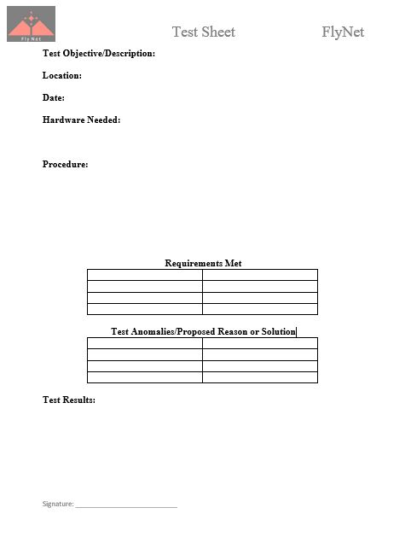

**Figure &: Test Sheet Template**

Looking at the test plan, some of the tests were moved to the next semester. This was due to falling behind on the testing schedule. Each subsystem ran into issues that slowed progress during the semester. This resulted in the scope for the semester not being completely met. Thus some tests ended up being unnecessary since they were outside the scope that would end up being reached. All of these tests were designed to lead up to an end of semester demonstration of the current functionality of the FlyNet system. That will be discussed in the following section.

**Final Test Demo-**

The initial goal for the final test demonstration was to show that the FlyNet system could fly autonomously through a building, while also mapping the building throughout. The floorplan of the building was to be known but some added unknowns were to be added to prove the system could adjust mid mission to correct its course and prevent collision. In order to add unknowns to the space, various “roadblocks” would be added to the building that were unknown to the system. These would be obstacles that the system would have to correct its trajectory to fly over or around. Also a complete block would be added to simulate a hallway that is no longer accessible or safe to fly through. A detailed image of the final demo setup can be found below in Figure @. It is worth noting that while the target identification was never part of the scope for this semester, the target still needs to be imaged in the building map.

Since the project could only fly in the Fleming RECUV lab, the goal was to create a mock up floor plan of a one story building. In order to make the floorplan as realistic as possible the area was designed to maximize the available flying space. An area of 24’x48’ was about the maximum area that the VICON cameras could cover so this was the designed size of the floorplan. While VICON would not be used in the demonstration for location purposes, it would be used as the truth to compare the quadcopter’s computed position to. The floorplan was designed to include multiple rooms, hallways, and doorway sizes. The floorplan can be found below in Figure @.

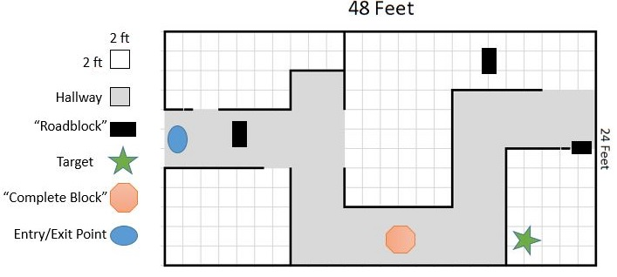

**Figure @: Floorplan for Final Demo**

Each small square is 2’x2’ so all of the hallways, which are shaded grey, are 6’ wide. The hallways include right and left turns, as well as a dead end. The smallest doorways were designed to be 3’ wide, which is the size of an average door, while the larger doorways were designed to be 6’ wide.

A floorplan of this size needed to be designed in a way that it could easily be taken down and stored since the Fleming Lab is a shared space. So the walls couldn’t be permanent and needed to be easy to disassemble and move. Assuming that one of the walls in the Fleming lab could be used as one of the 48’ walls, nearly 200 linear feet of walls needed to be constructed. With that much material, the wall design also needed to be cheap. 4’x8’ sheets of plywood or R-Tech insulation foam were determined to be the best candidates for the wall material. Since the walls did not need to full height in order to prove the concept, 4’ tall walls were sufficient. This meant that a 4’x8’ sheet could span 8 linear feet. This resulted in 26 sheets required to build the floorplan. The price of plywood and foam were with $1 of each other, so considering the foam is much lighter and would be easier to maneuver, foam was chosen as the wall material. The foam is 1” thick and cannot stand on its own, so some kind of frame needed to be designed to hold it. Wood was the obvious choice due to its low cost, high strength, ease of manufacturing, and it is readily available. The wood frame design can be seen below in Figure $.

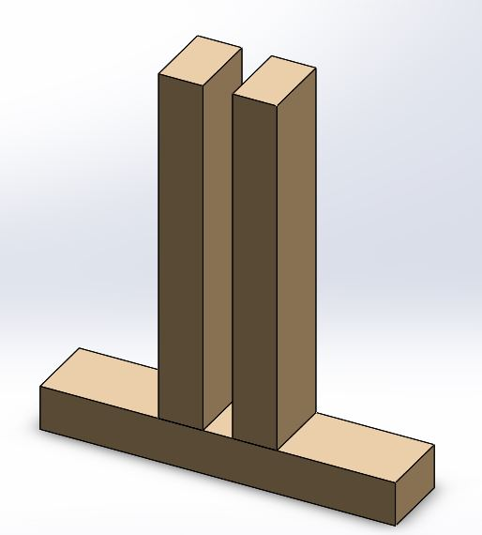

**Figure $: Wood Frame Design**

The wood frame consists of three 1’ pieces of 2x3. The two vertical pieces are secured using wood screws and are positioned to leave a 1” gap centered on the bottom piece. This allows for the foam to easily slide in and out of the frames and also provides enough support to keep the walls from fluttering or tipping when the quadcopter is flying near them. Since not all of the walls have dimensions of even multiples of 8’, there are some pieces of foam that need to be cut to 4’, 3’, and 2’ pieces. From a quick test flight, it was determined that two wood frames positioned at the bottom corners of these smaller wall segments were sufficient. The full 8’ wall sections need a third frame positioned at the mid span of the wall to prevent the wall from tipping.

To ensure that the final demo floor plan could be constructed and the design wasn’t flawed, a SolidWorks model was developed. This was done to iron out how all of the walls need to be positioned in order to eliminate any potential gaps or issues that had not been apparent previously. An image of the final result can be seen in Figure ^.

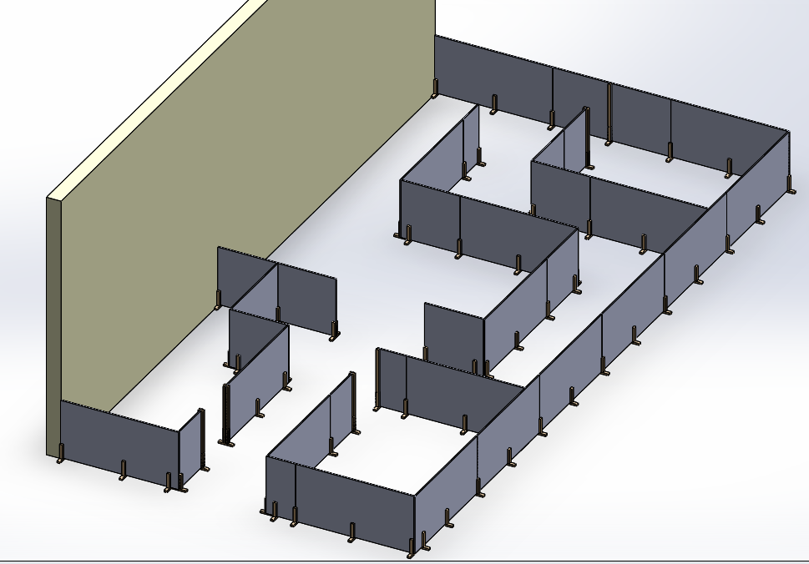

**Figure ^: Final Demo SolidWorks Model**

This model proved to be useful due to the accuracy and ideal solution that SolidWorks can provide. Using this model helped eliminate any 1” inconsistencies that may have occurred when assembling this for the first time in the RECUV lab. The 3’ wide doorways have been reinforced with a 4’ piece of 2x3 in case of any slight bumps that may occur when navigating through the narrow opening.

As the semester went on, it was clear that the proposed final demo had a scope too far away from the functionality of the system. Therefore the final demo has been pushed to the following semester. Its scope may have to be adjusted but is a good benchmark to start from. From tests with the guidance sensor, it is clear that the carpeted floor in the RECUV lab is insufficient for localization. In the coming semester tests will need to be conducted with different flooring materials.